**S3 Bucket Creation / Versioning / Website-Hosting Assignments**

**Creation :**

1. Creating an S3 Bucket for file storage.

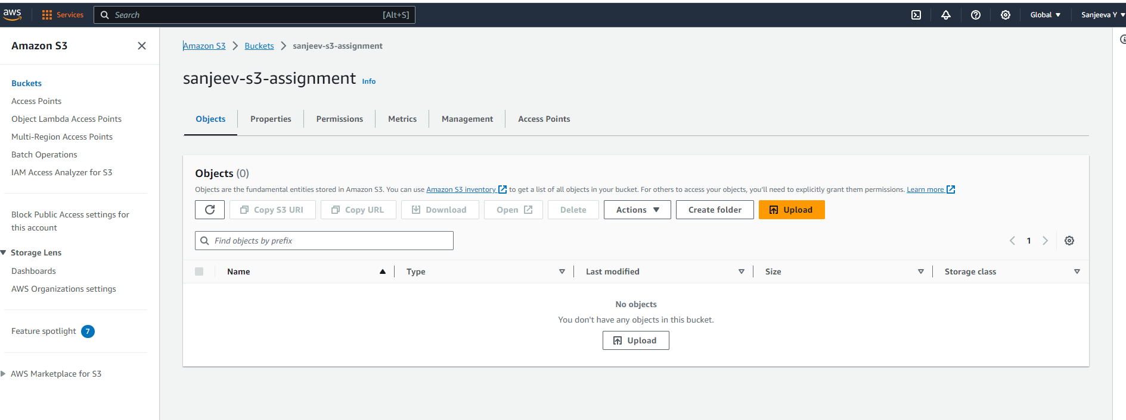

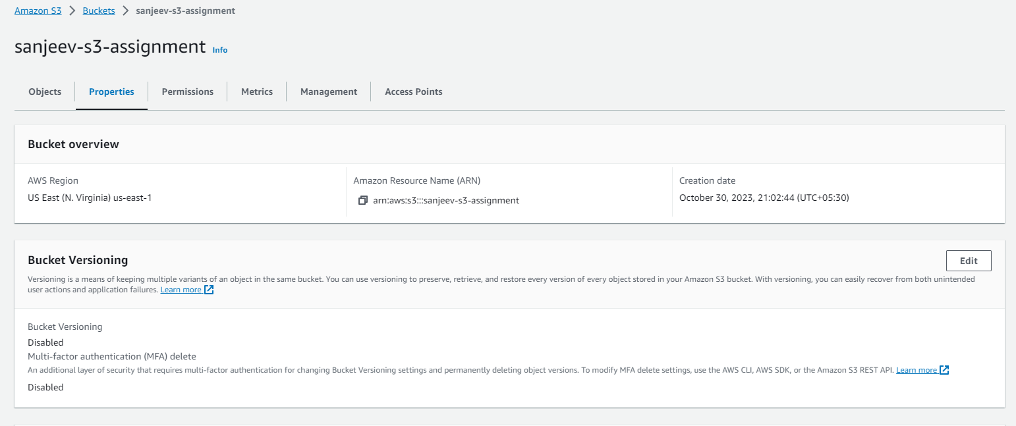

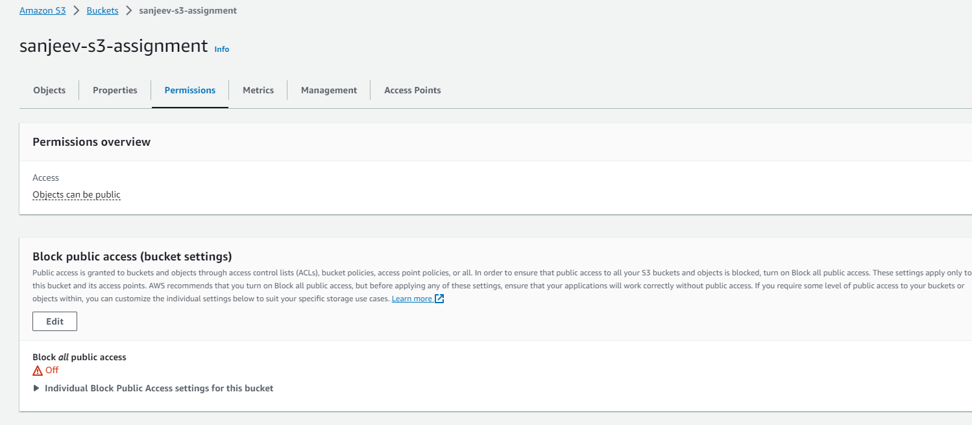

2. Uploading 5 objects with different file extensions.

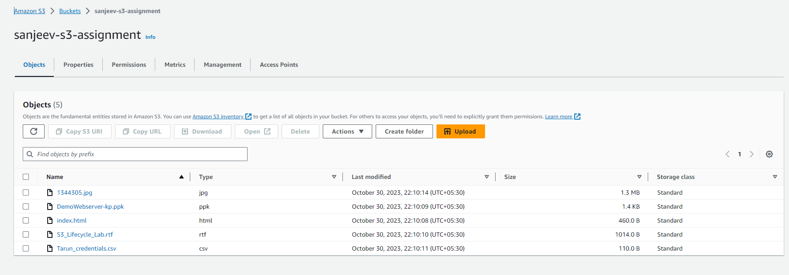

**Versioning :**

1. Enable versioning for the bucket created in task 1.

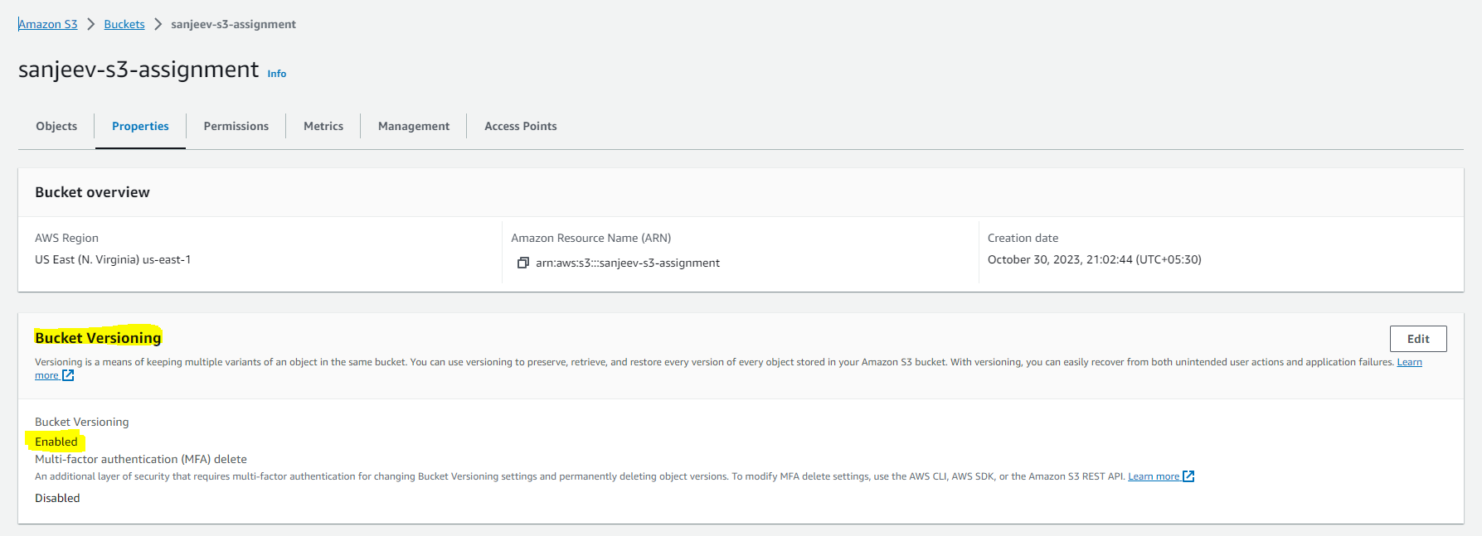

2. Re-upload 2 files already uploaded to verify if versioning works.

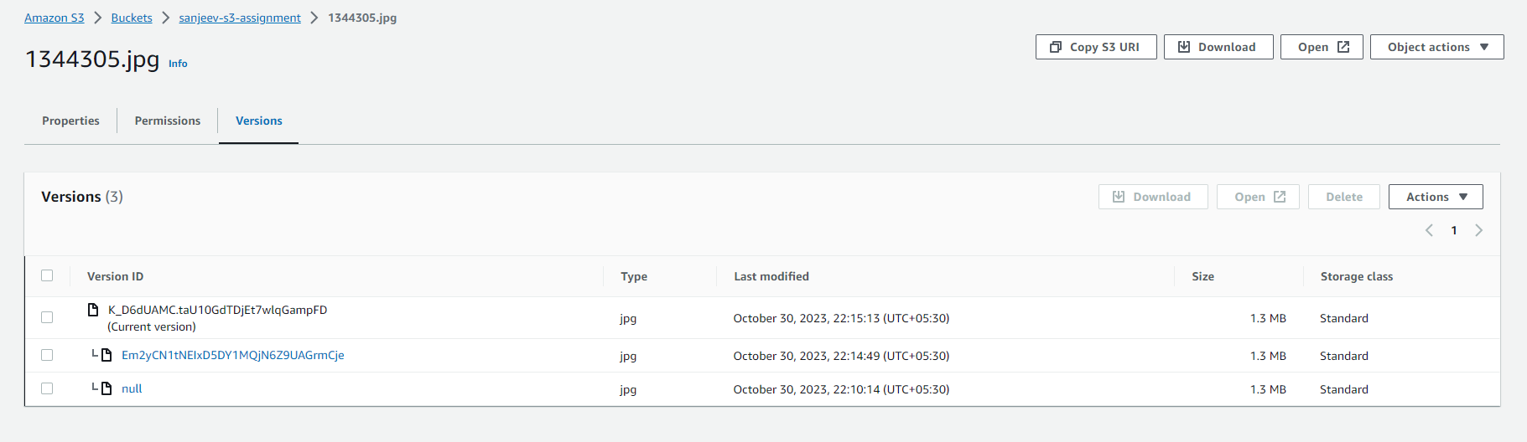

**Website-Hosting :**

1. Use the created bucket in the previous task to host static websites, upload an index.html file and error.html page.

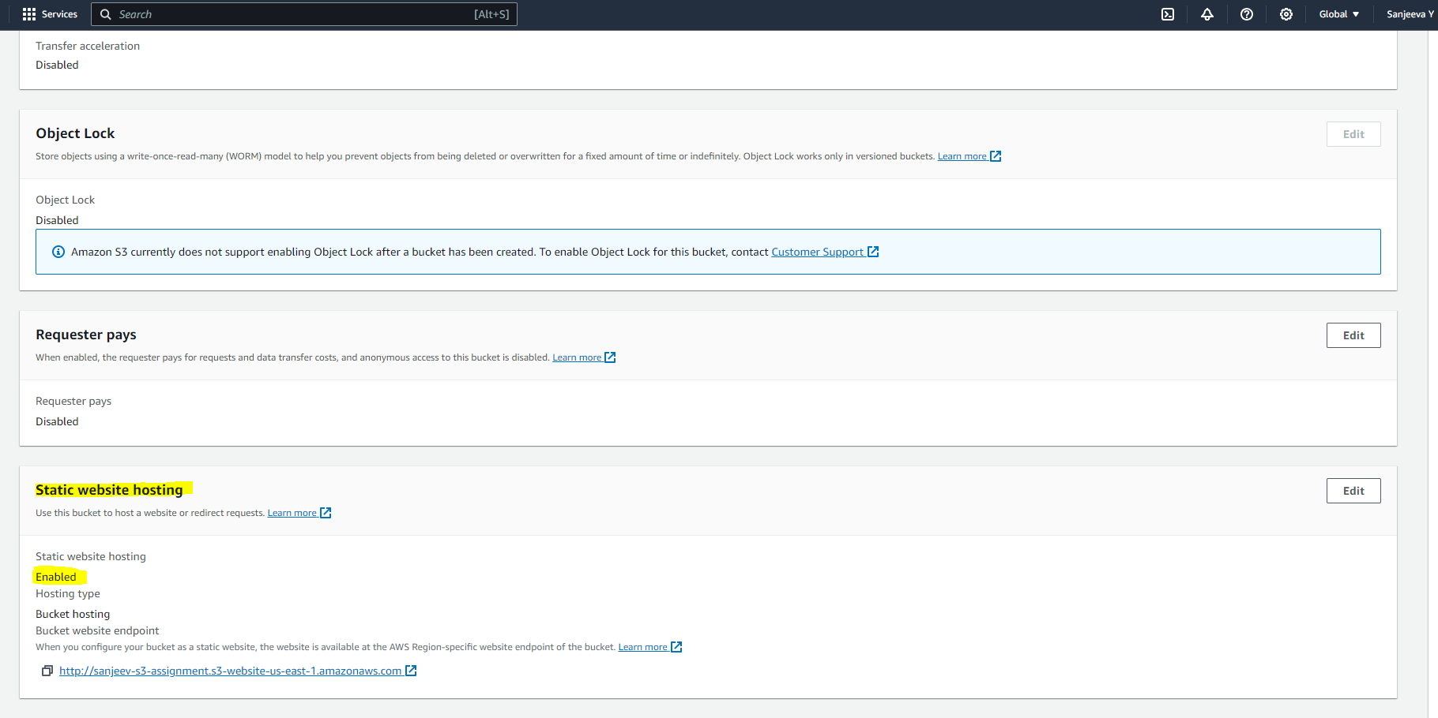

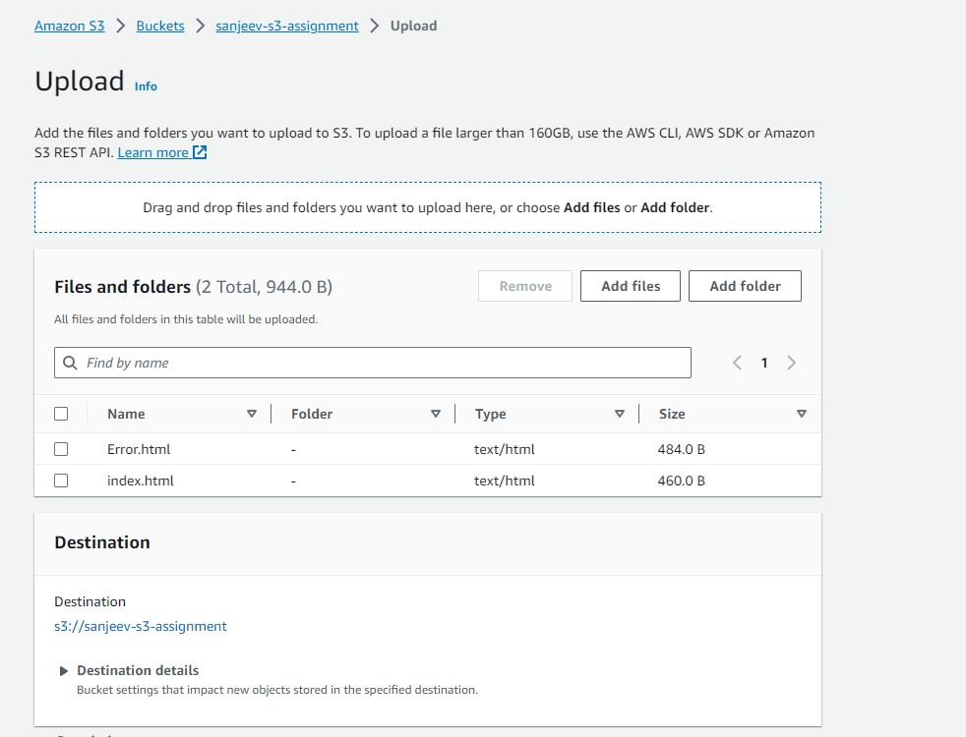

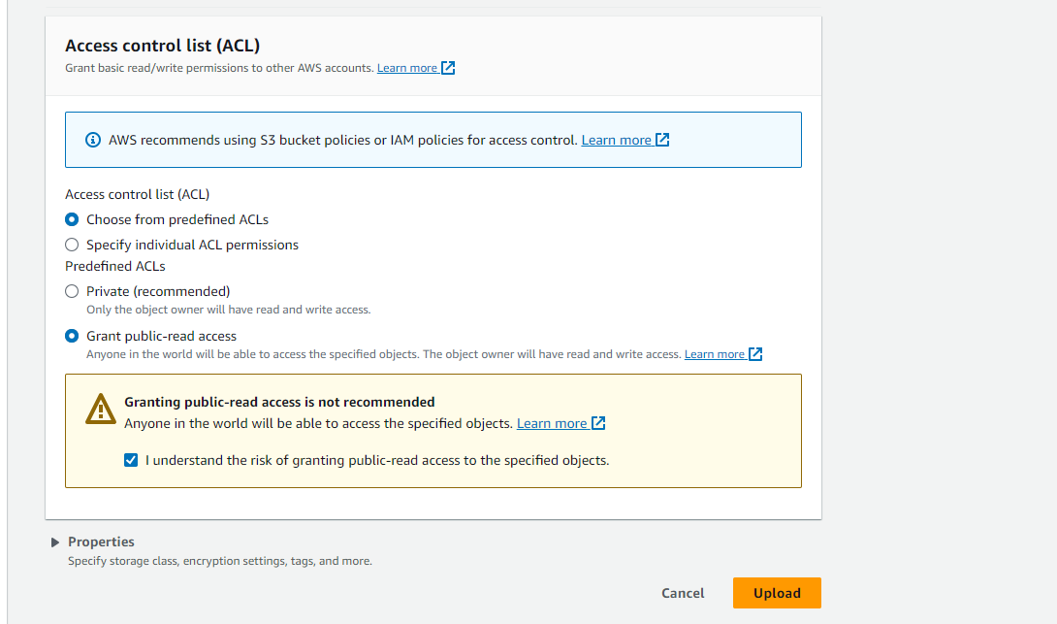

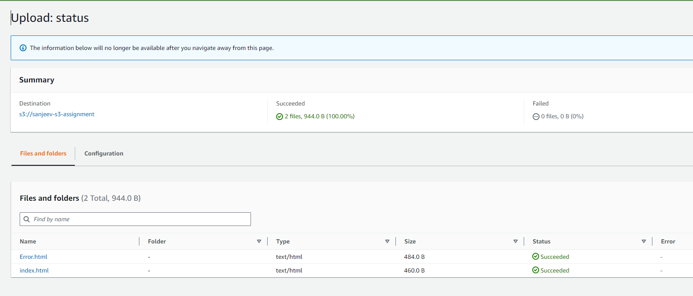

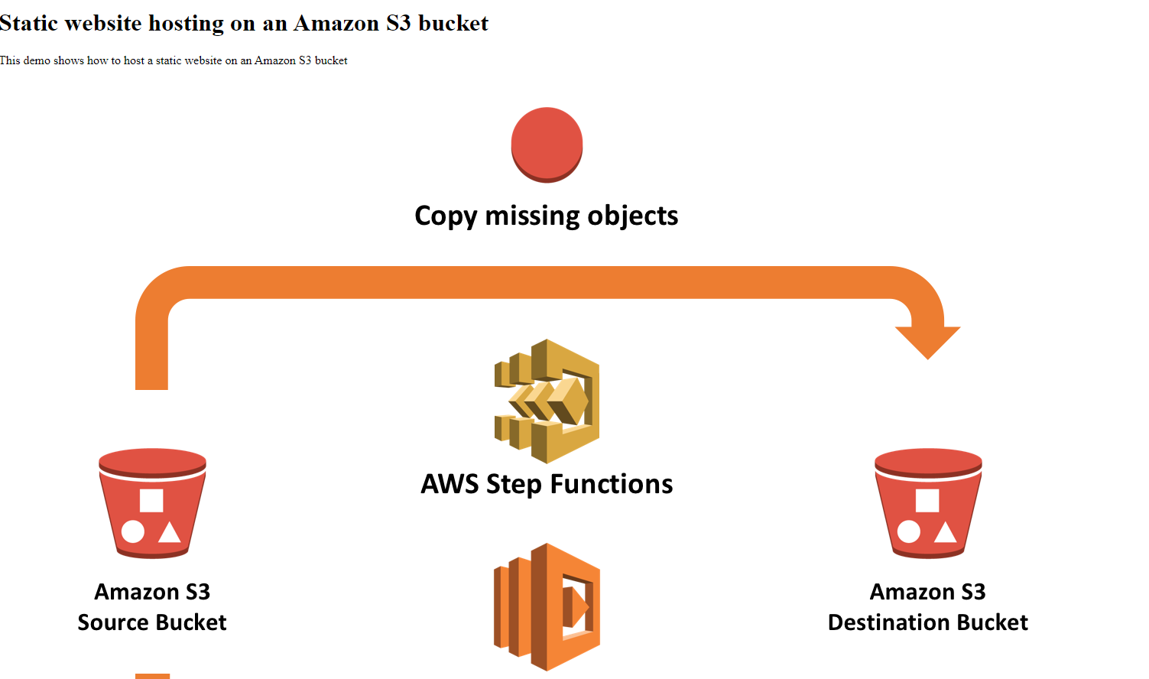

2. Add a lifecycle rule for the bucket:

a. Transition from Standard to Standard-IA in 60 days

b. Expiration in 200 days

